Create a dockerfile, file which when build must display your basic details in website

Install docker in the EC2 instance



Create dockerfile

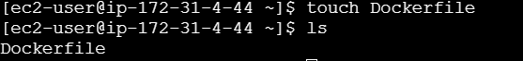

Open the dockerfile and enter the below commands to create a custom image that displays your basic details in website

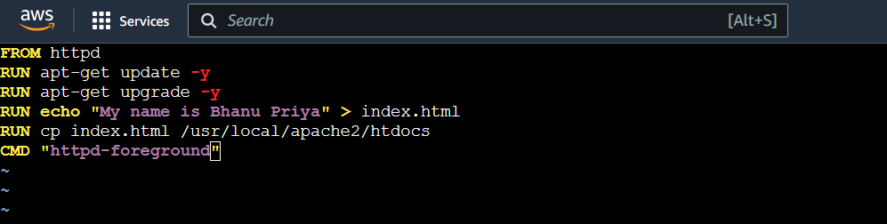

Once the docker file is created, build it to create a docker image.

**docker build . -t basic_det:v4**

Run the docker image as a container:

**docker run -p 84:80 -dit basic_det:v4**

Check if the container is running or not using:

**docker ps -a**

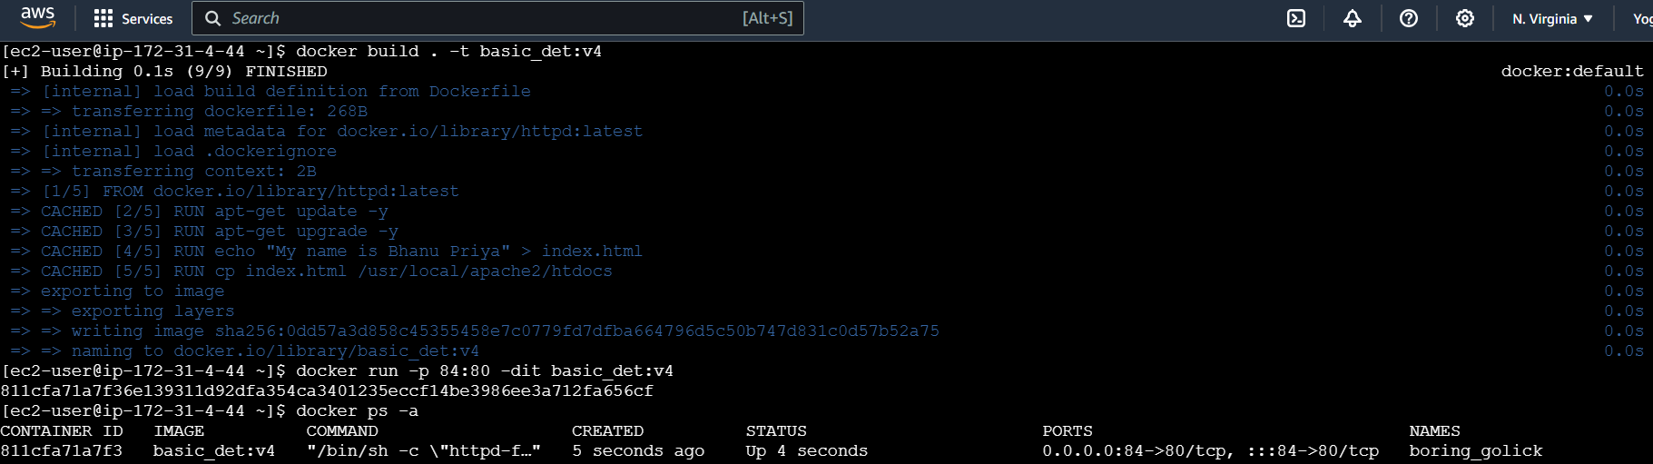

Under security group, edit inbound rules and add new rule **to allow all traffic from all source 0.0.0.0/0** to access it via any port

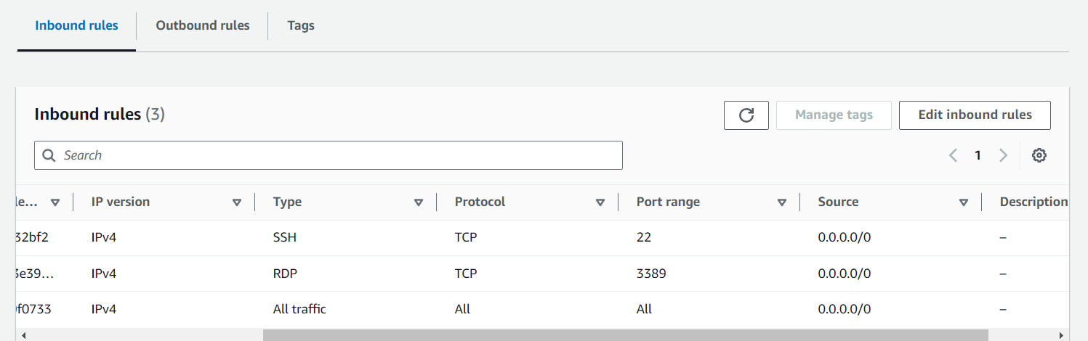

Access the instance via public ip with port 84

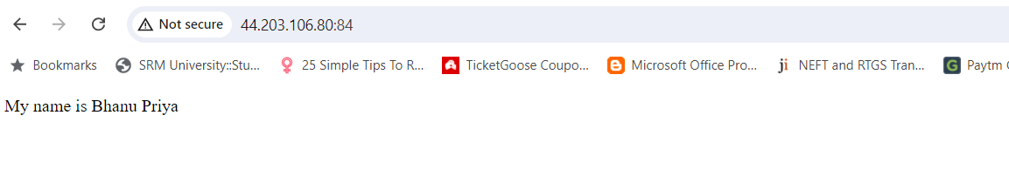Basic details are displayed in website.